Practicum No. 4 Date:
Register Transfer Operations

- Practical Significance

Simulating data transfer between registers helps students visualize how CPUs handle internal operations efficiently. Performing arithmetic operations at the register level builds understanding of processor speed and resource optimization. It also reinforces the concept of instruction execution and temporary data storage. These fundamentals are essential for exploring topics like pipelining and assembly language.

- Competency and Industry-Specific Practical Skills

This practicum exercise is expected to develop the following skills for the industry-identified competency.
- Evaluate the performance of scalable architectures for intelligent systems to ensure reliability.
(As stated in the Course Structure)
- Build register setup to run basic instruction steps. (PDO)

- Relevant CO(s) (As stated in the Course Structure)

- CO1. Evaluate the performance of the processor functionalities.

- Practical Outcome (PrO) (As stated in the Course Structure)

- Develop programs to perform data transfer operations for the given registers.

- Related ADO(s) (As stated in the Course Structure)

- Follow industry standards for system evaluation and performance optimization.
- Function effectively in teams to develop processor and memory architectures.
- Function responsibly in leadership roles to design computing systems.

- Minimum Underpinning Theory (Include relevant content & images for this practicum.)

To perform data transfer operations, students must understand the internal structure of the CPU, especially the register organization. Registers are small, fast storage locations within the processor used to hold data temporarily during instruction execution. Key registers include the accumulator (ACC), general-purpose registers, and instruction registers. Data transfer operations involve moving data between registers, between memory and registers, or between input/output ports and registers. These operations form the foundation for all processing tasks and are controlled through specific machine instructions.

Students should also understand the instruction cycle, particularly how data is fetched from memory and transferred to registers using instructions like MOV, LOAD, and STORE. They should become familiar with how control signals activate data paths within the CPU to move data between components. Additionally, learners must understand bus systems, such as data, address, and control buses, which facilitate these transfers.

The ability to perform and simulate such operations using a tool like MATLAB will strengthen understanding of low-level data handling in computer systems.

- Algorithm (Include probable photos of experimental set-up.)
- Start the program.
- Initialize registers:
- Set register AX = 5
- Set register BX = 10
- Display initial values of registers AX and BX.
- Transfer data from register BX to register AX (i.e., AX = BX).
- Display values of registers after the transfer.
- End the program.

Key Concept for Students:

- Register = small storage inside CPU.
- Transfer means copying data from one register to another.
- After transfer, both registers can hold the same value.

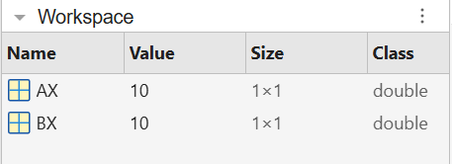

- Resources Required

S. No. | Resource | Suggested Broad Specification | Quantity
1 | Laptop | Intel Core i5/i7 processor, 8GB RAM, Windows OS recommended for 8086 emulator | 1 No.
2 | 8086 Emulator | EMU8086 Microprocessor Emulator  https://emu8086.en.lo4d.com/windows | 1 No.
3 | MATLAB | https://matlab.mathworks.com/ | 1 No.

- Safety Precautions

- Do not run unfamiliar or unverified scripts found online which may harm your computer.
- Verify your register usage and memory addresses to avoid system-level crashes or infinite loops.
- Close all other programs before executing large or unknown assembly code to free up resources.
- Use licensed version of MATLAB to avoid security or legal issues.

- Procedure (Self-Instructional)

- Switch on the computer.
- Open MATLAB on your computer.
- Create a new script file (File → New → Script).
- Run the following MATLAB script and note the values on the console.
% This script simulates data storage and transfer between CPU registers
% Step 1: Assign initial values to registers
AX = 5; % AX register holds the value 5
BX = 10; % BX register holds the value 10
% Display initial values
fprintf('Initial Values:\n');
fprintf('AX = %d\n', AX);
fprintf('BX = %d\n', BX);
% Step 2: Transfer value from BX to AX
AX = BX; % Data transfer from BX to AX
% Display values after transfer
fprintf('\nAfter Transfer (AX = BX):\n');
fprintf('AX = %d\n', AX);
fprintf('BX = %d\n', BX);

Observe and note the output:
Command Window:
Initial Values:
AX = 5
BX = 10
After Transfer (AX = BX):
AX = 10
BX = 10
>>
Output:



- Shut down the computer.

- Actual Resources Used

S. No. | Resource | Suggested Broad Specification | Quantity
1 | Laptop | Intel i5, 8GB RAM | 1
2 | MATLAB Software | MATLAB R2021a | 1
3 | Operating System | Windows 11 | 1

- Actual Procedure Followed
- The computer system was switched on and MATLAB software was opened.
- A new script file was created using File → New → Script in MATLAB.
- The MATLAB program for simulating data transfer between CPU registers (AX and BX) was written in the script editor.
- Initial values were assigned to the registers AX and BX.
- The program was executed using the Run button in MATLAB.
- The values of registers before and after the transfer operation were observed in the Command Window and Workspace.

- Observations

S. No. | Observations | Data | Remarks
1 | Initial value stored in AX register | 5 | Assigned manually
2 | Initial value stored in BX register | 10 | Assigned manually
3 | Data transfer operation performed | AX = BX | Value copied
4 | Final register values | AX = 10, BX = 10 | Transfer successful

- Results/Observations
- The MATLAB program successfully simulated the transfer of data from register BX to register AX. After execution, AX contained the value of BX while BX remained unchanged.
- The output verified that register data transfer operation (AX ← BX) works correctly, which represents how processors copy data between registers.
- Interpretation of Results

The obtained results show that MATLAB can be used to simulate basic processor register operations. When the instruction AX = BX was executed, the value stored in register BX was copied to AX without affecting the value of BX.
This demonstrates the concept of data transfer between registers in a CPU, which is commonly used during instruction execution in processors.

- Conclusions

The experiment successfully demonstrated how register data transfer operations work in a processor system using MATLAB. The program showed that data can be copied from one register to another without altering the source register.
This concept is fundamental in computer architecture and instruction execution cycles, where registers are used for storing and transferring intermediate data during processing.

- Suggested Practicum Related Questions:

Note: Below are a few questions related to industry-specific higher-order thinking skills (HOT) that teachers must use to ensure students achieve the predetermined course outcomes.
- In a simple processor system, a control unit needs to copy the value from one register to another register so that the same data can be used for further computation without altering the original value. Write a MATLAB program to simulate the transfer of data from Register A to Register B. Display the values of both registers before and after the transfer operation.

CODE:

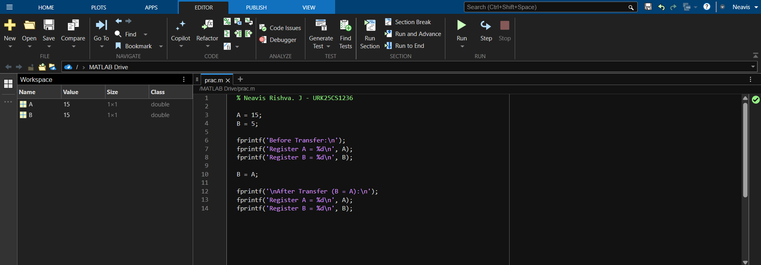

OUTPUT:
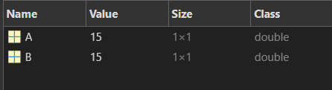
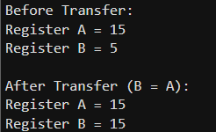

- In a digital processing unit, several registers store intermediate results. The processor may need to move data from one register to another for executing instructions efficiently.Develop a MATLAB program to simulate the transfer of data from Register R1 to Register R3 while maintaining the value in Register R2. Display the contents of all registers after the transfer.

CODE:
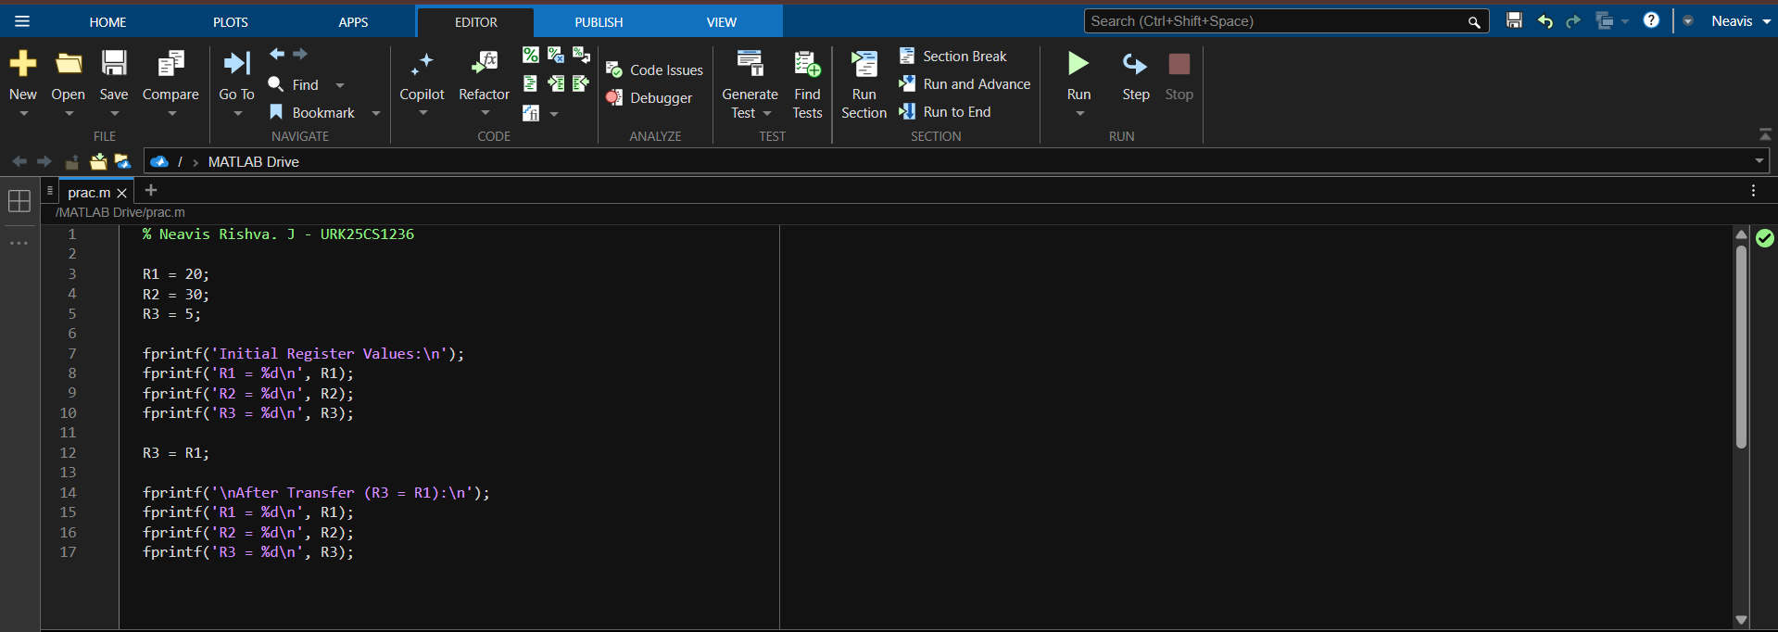

OUTPUT:
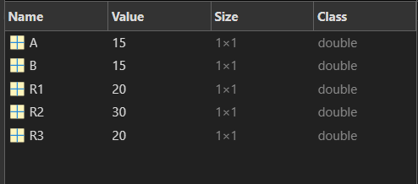
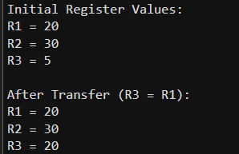

- During certain arithmetic operations in a processor, the contents of two registers must be exchanged to rearrange operands for the next instruction cycle.Write a MATLAB program to swap the contents of Register R1 and Register R2 using a temporary register and display the updated values.

CODE:
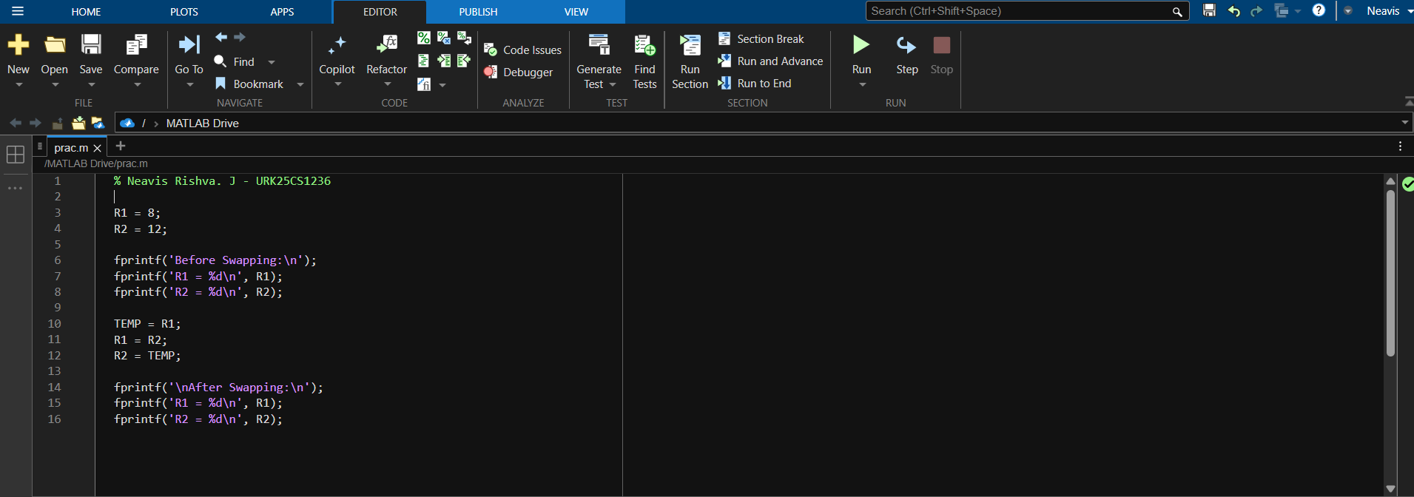

OUTPUT:
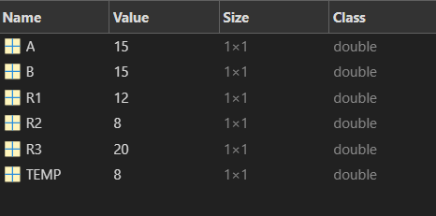

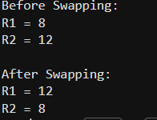

- A processor retrieves instructions and data from memory during execution. The fetched data from a particular memory location must be transferred to a register for processing.Assume an array represents memory locations in MATLAB. Write a MATLAB program to transfer data from a specified memory address to Register R1 and display the retrieved value.

CODE:

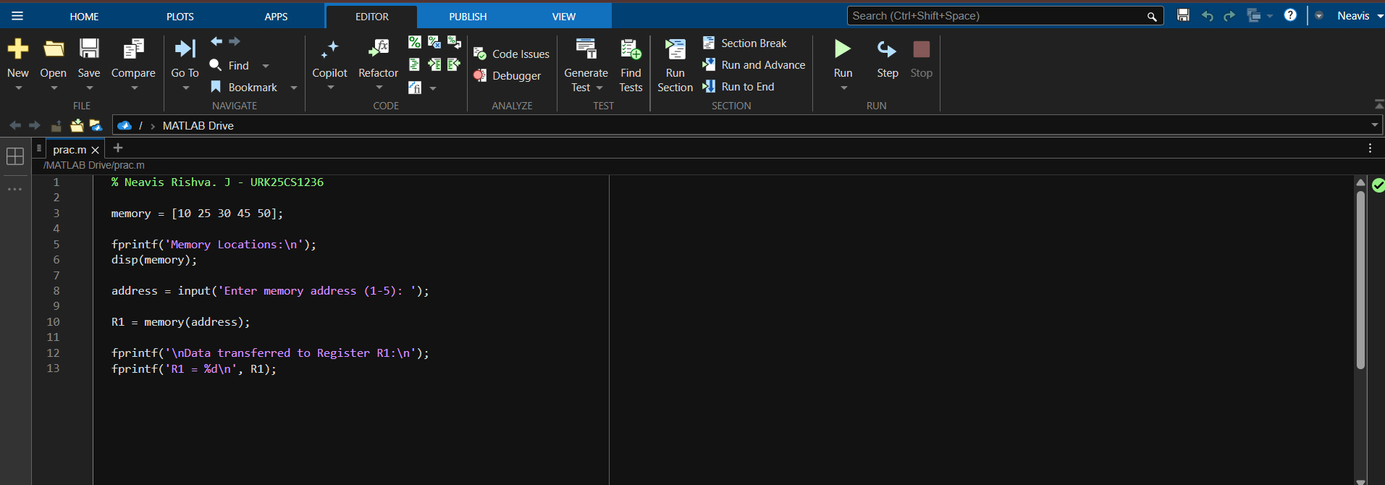

OUTPUT:
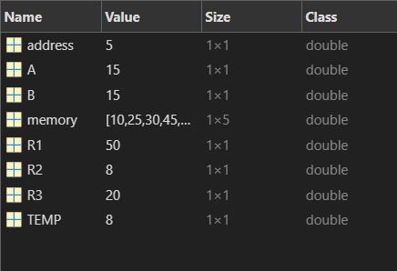

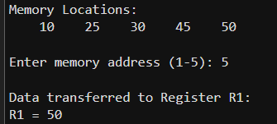

- References / Suggestions for further reading

- Data Transfer Instructions in 8086 Microprocessor: https://www.geeksforgeeks.org/computer-organization-architecture/data-transfer-instructions-8086-microprocessor/
- Assembly Registers: https://www.tutorialspoint.com/assembly_programming/assembly_registers.htm
- Types of Registers in 8086 Microprocessor:
https://www.geeksforgeeks.org/electronics-engineering/types-of-registers-in-8086-microprocessor/
- 8086 Microprocessor Architecture:
https://microcontrollerslab.com/8086-microprocessor-architecture/
- Stack Introduction – PUSH & POP - YouTube – Education 4u
- Stack Organization – Register and Memory Stack – YouTube – Education 4u
- RISC and CISC Architecture - https://intellipaat.com/blog/difference-between-risc-and-cisc/

- Suggested Assessment Scheme

The performance indicators given serve as a guideline for assessing the ‘process-related skills/LOs’ (marks to be awarded in real-time in the laboratory by the faculty member, as these cannot be measured after the practicum is over) and ‘product-related skills/LOs’

Note: The weightage for the process-related skills and product-related skills will change depending on the PrO, COs, and the competency related to the concerned course.

Performance Indicators |  | Maximum Marks | Marks Obtained
Process-related Skills: 18 Marks - 60%
 | Follow industry standards | 3
 | Function effectively in teams | 2
 | Function responsibly in leadership | 3
 | Build register setup to run basic instruction steps. | 10
Product-related Skills: 12 Marks - 40%
 | Uses correct commands or syntax in Tool | 3
 | Results | 3
 | Interpretation of Results | 3
 | Conclusion | 3
Total |  | 30

To be filled by Student:

S.No. | Name of the Student | Register No.
1 | NEAVIS RISHVA. J | URK25CS1236

To be filled by the Faculty Member:
Marks Obtained |  |  | Name and Designation of the Faculty Member | Date of Evaluation
Process-Related Skills  (18) | Product-Related Skills (12) | Total  (30)

*******

